Ophthalmology Department

Telephone: 0121 424 2000
Information for Patients

Trabeculectomy - Information for Patients

This information has been written to help you understand what a trabeculectomy operation is. Although we hope to cover all the important points about the operation if there are still questions that you have, it is very important that you discuss this with the doctor or other members of staff involved in your care.

You will not notice an improvement in your vision after this operation. In fact it is likely that your vision will be slightly worse for approximately 4-8 weeks following surgery. However the operation is intended to reduce further reduction in vision due to glaucoma.

In the normal eye the fluid (aqueous) drains away through a sieve like structure called the trabecular meshwork. If the meshwork is narrow or becomes clogged up for any reason, pressure will build up inside the eye causing pressure on the nerve carrying visual impulses to the brain (optic nerve). It may also reduce the flow of blood to parts of this nerve. Damage to the nerve may cause portions of vision to be permanently lost.

Treatment available for glaucoma
The initial treatment for most forms of glaucoma is eye drops to reduce the pressure within the eye. These need to be used every day for life. Different types of laser are used in certain forms of glaucoma with the aim of lowering the pressure in the eye. When glaucoma continues to progress despite the use of drops or laser treatment your consultant may recommend a trabeculectomy. In some case a trabeculectomy may be recommended as an initial procedure. The choice of treatment depends on the type of glaucoma and whether the patient can put drops in.

What is a trabeculectomy?
It is an operation to control the pressure inside the eye in patients with glaucoma. The surgeon forms a small channel through the white part of the eye (sclera) which allows the fluid made naturally in the eye (aqueous) to drain out. It drains into a small pocket (bleb) on the surface of the eye under the upper lid and it gets absorbed into the circulation.

Some patients need an injection of a special medication (mitomycin or fluorouracil) around the incision site to reduce scarring and ensure the channel does not close too soon after the surgery. These injections may need to be repeated in the out – patient department following the operation. This operation is performed by an experienced eye surgeon or they may supervise a doctor during their training.

Is there a waiting list?
There is a short waiting list for all operations. The maximum time you will have to wait should be 12 weeks. If the operation is urgent it may be a lot less.

Pre-operative Assessment

To reduce the risk of bleeding during the operation we usually ask you to stop medicines like aspirin, clopidogrel or warfarin. It is important to talk to us first though, to make sure it is safe to stop taking any tablets, as you may need heparin injections instead. Don’t just stop taking them!

In most circumstances you will have the operation performed under a local anaesthetic, which means you will be awake during the surgery. You will be asked to keep your eye still and lie as flat as possible.
This procedure will only be carried out with your consent and you will be asked to sign a consent form when you are put on the waiting list.

Before the operation you will have a small injection around the eye which will make the eye numb and will also prevent the eye moving and may blank out the vision during the operation.

If your general health is good, then you could have a general anaesthetic, which involves you being asleep throughout the operation.

How is the operation done ?
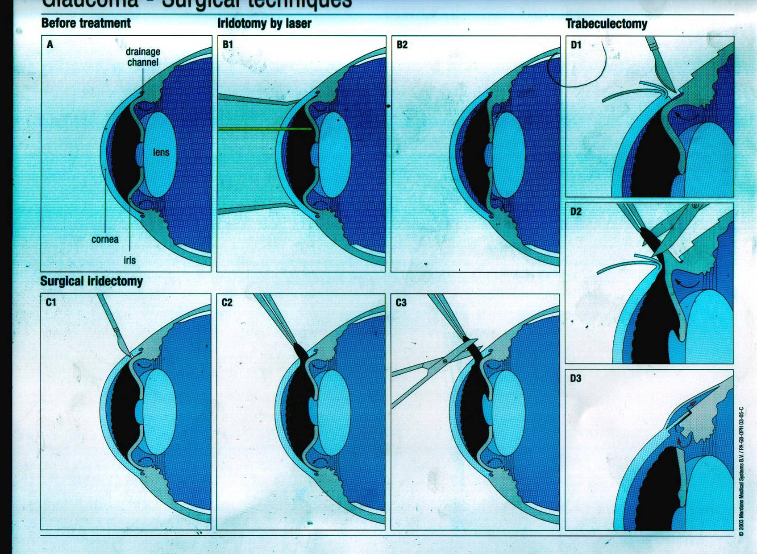
After cutting the skin on the eye (conjunctiva) a small flap is made on the outer, white layer of the eye, (the sclera) and a small hole is made into the eye underneath it.

At the end of surgery all the layers are closed with stitches.
After a few weeks a small blister forms at the site of surgery called a bleb, which remains on the eye beneath the upper eyelid (so you can’t normally see it).

The bleb collects the aqueous from inside of the eye in a controlled way and lets it absorb into the circulation. This lowers the pressure in the eye.

Benefits of trabeculectomy surgery
To prevent visual loss by lowering the pressure in the eye

Possible complications from the surgery
These might mean that the operation doesn’t work properly and we might have to give you drops or do other operations to try to fix it.

Problems with the operation

Inflammation and scarring can stop the fluid draining out, which makes the pressure go up and you may need drops, injections or surgery.

The wound can leak, which gives a very low pressure and you may need surgery to seal it up.

Other problems

Complete loss of vision is very rare and is seen in less than 1:5000 patients

Infection is rare, but is an emergency if it happens

Bleeding inside the eye: the risk is higher if you are taking blood thinning medicines e.g. aspirin, warfarin or clopidogrel.

Cataract: if you already have an early cataract this operation might make it worse so you would need cataract surgery. If it is a problem the doctor will discuss it with you after the operation.

Droopy eyelid and double vision may get better on their own or you may need special glasses or surgery.

Retinal detachment (which can lead to sight loss)

Allergy to the postoperative medications.

How long will I be in hospital?
In most cases the operation will be performed as a day case at Solihull Hospital Day Procedure Unit which is on the first floor of the hospital opposite the restaurant.

You should have a responsible adult to come with you, as an escort.
If you are fit to travel, you may come in on public transport or taxi, otherwise arrangements will have to be made for hospital transport if you do not fall into this category.

If your operation is in the morning then you can have a light breakfast, if it is in the afternoon you may have a light lunch. If you are a diabetic patient have your normal diabetic diet.

Take all your medications as normal unless instructed otherwise by the doctor.

Wear loose comfortable clothing, no jewellery and no makeup. You will be able to wear your own clothes during the operation. After the operation you will be able to go home within a few hours.

After the operation
In most cases, an eye pad and plastic shield will be placed over your eye after surgery. The next day you can remove this dressing and put in your drops as instructed.

Pain is unusual after this operation but the eye may feel tender. A mild pain reliever like paracetamol is usually enough to make it feel better. Sudden, severe or deep-seated pain should be reported immediately using the numbers provided.

Do not be alarmed if the vision in the eye is worse than it was before the operation, this is normal. It can take up to 8 weeks before the vision is the same as it was before.

Stop Glaucoma drops to the eye which has been operated on but continue to use those prescribed to the other eye.

After surgery Avoid

- Lifting heavy objects
- Vigorous head shaking
- Rubbing the eye
- Using eye make-up
- Swimming
- Driving until after your first outpatient appointment when this can be discussed with the doctor.

Ensure you

- Wash your hands before putting in your drops
- Wear the eye shield provided overnight for at least two weeks after surgery
- Continue to use eye drops as instructed and if you run out of eye drops get a repeat prescription from your GP surgery.
- When bending down do so slowly and try to keep your head in the upright position
- Wear sunglasses to make the eyes more comfortable in bright light

DO

- Read
- Watch T.V.
- Go for walks
- Cook

Will the operation improve my sight?

Unfortunately the operation cannot bring back any sight that has already been lost. After the operation your sight may be blurred and seem worse but this is only temporary. Your eye will need time to heal and this generally takes approximately 8 weeks.

How often will I be seen in clinic after the operation?
To ensure that all is going well you will need to be seen regularly in the eye clinic. Visits will tend to be as follows:
- The day following the operation
- A week after the operation
- Then every two weeks for approximately six weeks
- Monthly for three months

This may be altered depending on what the doctor sees on examination.

Contact Details:
Good Hope Sheldon Unit (0121) 424 4664
Solihull eye clinic (0121) 424 4463
Heartlands eye clinic (0121) 424 0543

If you have any problems at the weekend, Bank Holidays or after 5pm please contact Birmingham and Midland Eye Hospital on (0121) 507 6780

